Registration Process for Cyber Security Virtual Fair:
For international companies and public sector organizations

All participants need to first register via the Eventtia platform. On the platform, select your attendee type Pre-screened international companies and public sector organizations and enter in your Attendee information. First-time registrants, skip the “continue registration” field. If you have already registered, you can use the “continue registration” option to request to update your existing attendee profile instead.
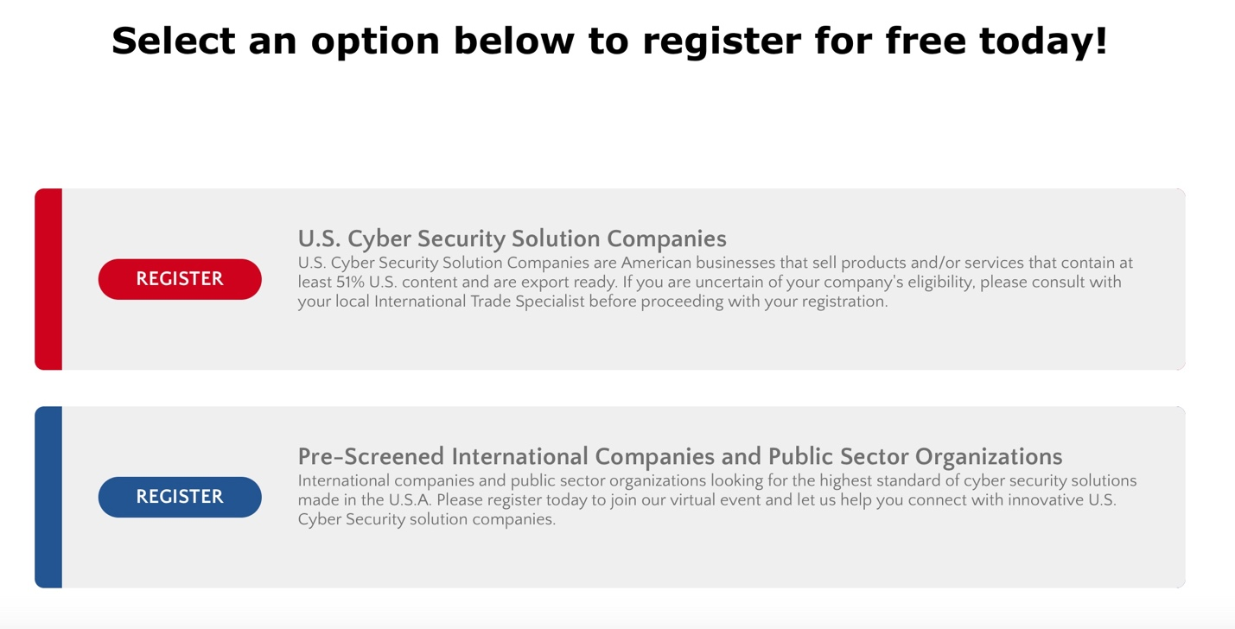

After you register via the Eventtia platform, you will be taken directly to the screen shot below

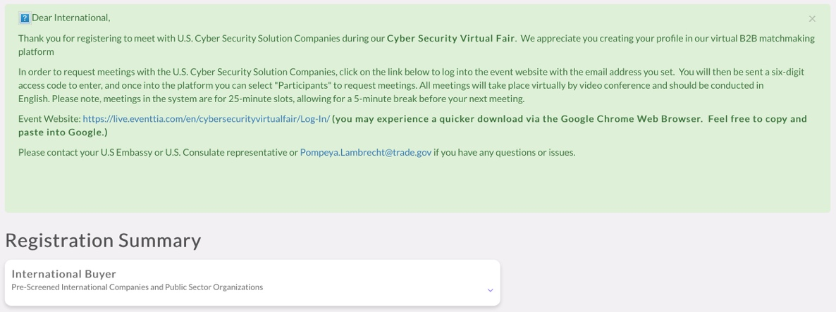

How to Access the Virtual B2B Matchmaking Platform

All participants who have registered can access the Virtual B2B Matchmaking Platform at: https://virtual-stage.eventtia.com/en/cybersecurityvirtualfair/login using their e-mail address.
Step 1: After clicking on the above event weblink, the registrant will be prompted to the Login Page (below), enter e-mail and "click" Login.
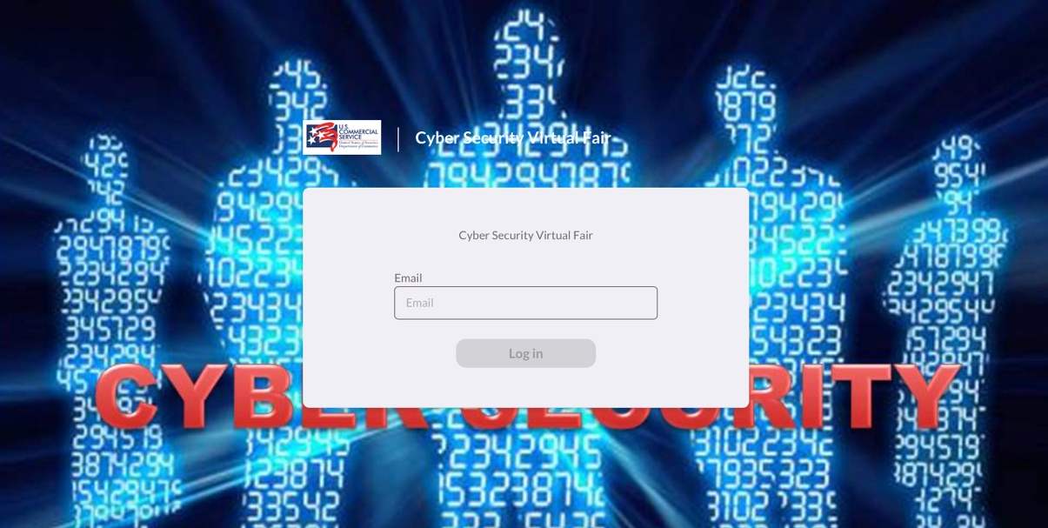

Step 2: Shortly thereafter (please allow 1-2 minutes), a 6-Digit Security Code will be sent via Email from Pompeya Lambrecht (be sure to check Spam folders) to gain access to the online platform.

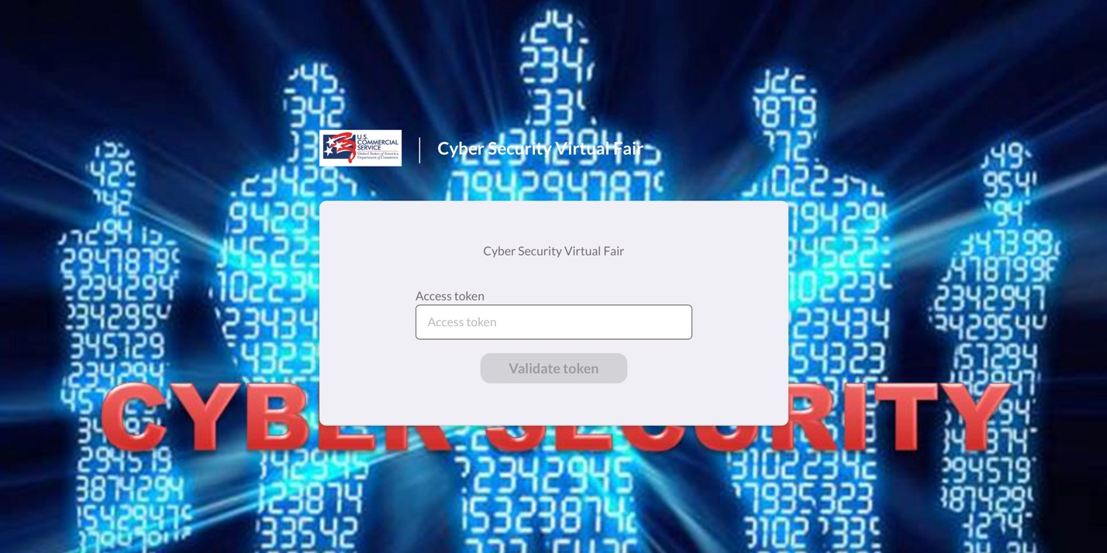

Step 3: After entering the access code you will have access to the platform where you can select the Attendees icon on the left to begin searching for U.S. Cyber Security Solution companies.

Step 4: After clicking on the “Attendee” icon, you can filter and sort by product categories as shown below:
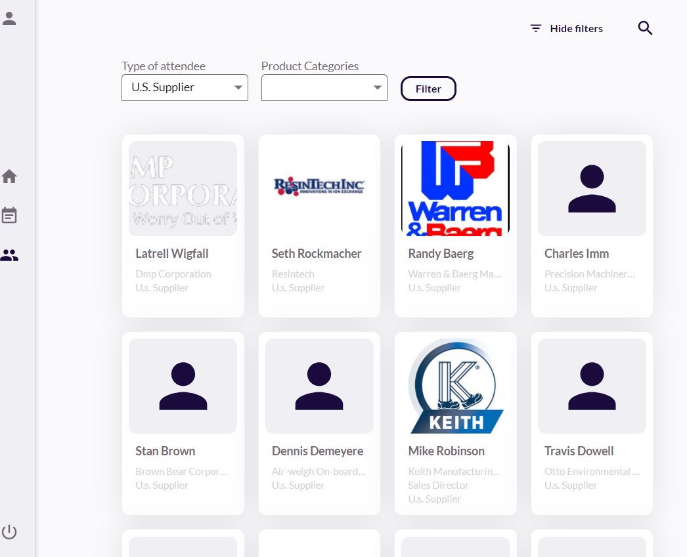
Step 5: Click on each company to display their profile and to request a virtual (video) Meeting with them:
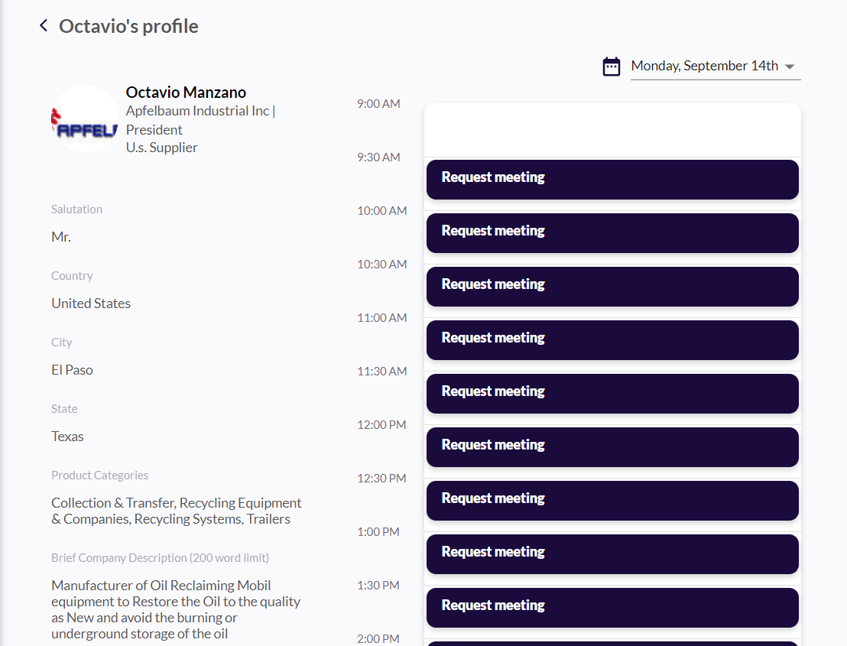

Step 6: On the day of the meeting, you can return to the platform and click “Join” to launch the meeting and connect with the U.S. Cyber Security Solution companies.
