Global Technopreneurs Registration Guide
STEP - 1 Click on REGISTER NOW

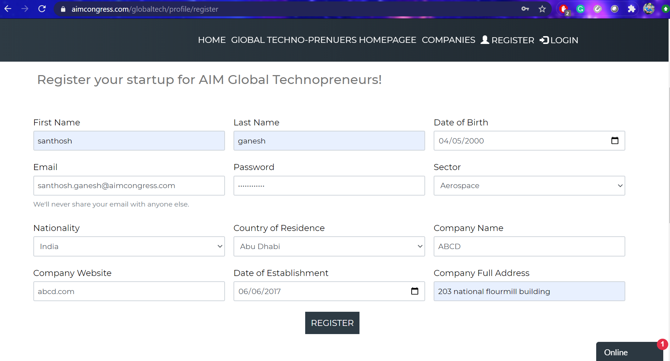
STEP -2 Fill in the required details. Page 1

STEP -2 Fill in the required details. Page 2
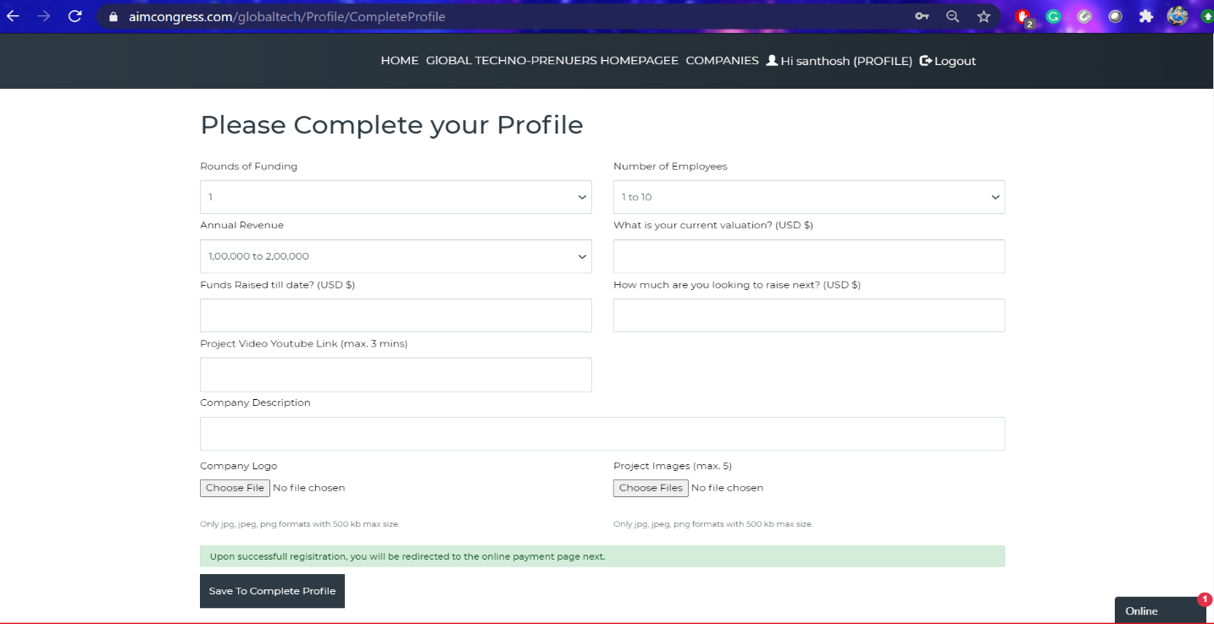
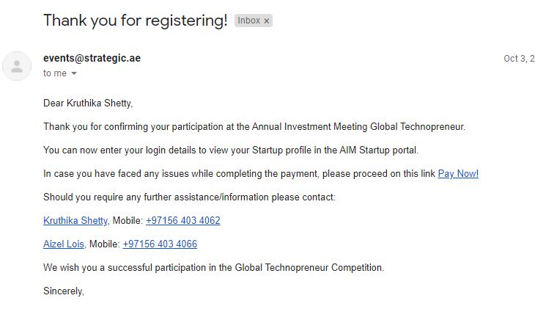
*IN CASE YOU ARE NOT DIRECTED TO THE EVENTS10X PAGE AUTOMATIVALLY, PLEASE CHECK YOUR EMAIL AS YOU WOULD RECEIVE A NOTIFICATION OF REGISTRATION WITH THE LINK TO COMPLETE PAYMENT*

Step - 3 After you finish the last step on the aim portal, it will open automatically into Events10x page to complete online payment.
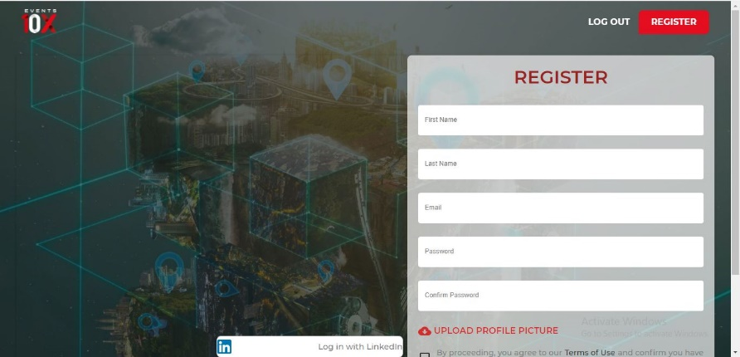
Make a profile on events10x – event platform for aim digital 2020

Once registered on events10x, fill in company details and register as startup. put areas and countries of interest and proceed for payment.
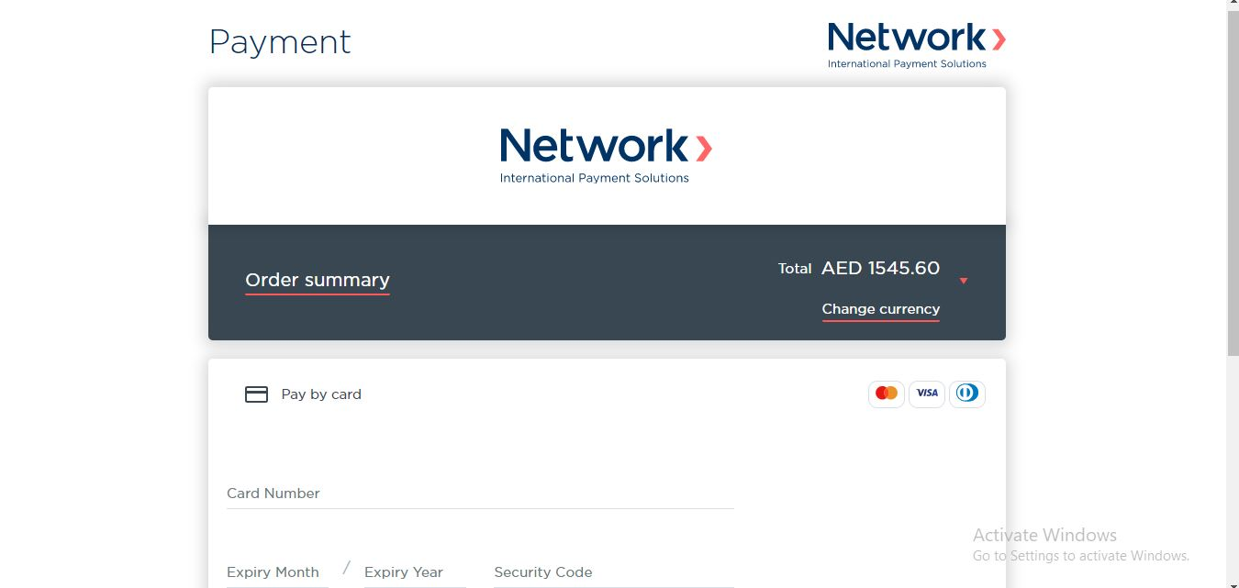
Step -4 Online payment to complete Global Technopreneurs registration

